Structure analysis calculator:

Powerful tool for engineers, architects

and researchers can use to evaluate the behaviour

of different kinds of structures.

Structure analysis calculator: This powerful tool for engineers, architects, and researchers can use to evaluate the behaviour of different kinds of structures.

This OOK calculator is a specialized tool designed for the analysis and design of structural elements, such as beams, columns, shafts, and members of varying cross-sections.

This calculator makes it easier to analyze and optimize section properties in detail for structural integrity, efficiency, and safety in a variety of construction projects

Easily calculate and visualize the geometric properties of various cross-section shapes, including moments of inertia, section modulus, centroid distances, and other critical parameters essential for structural analysis and design.

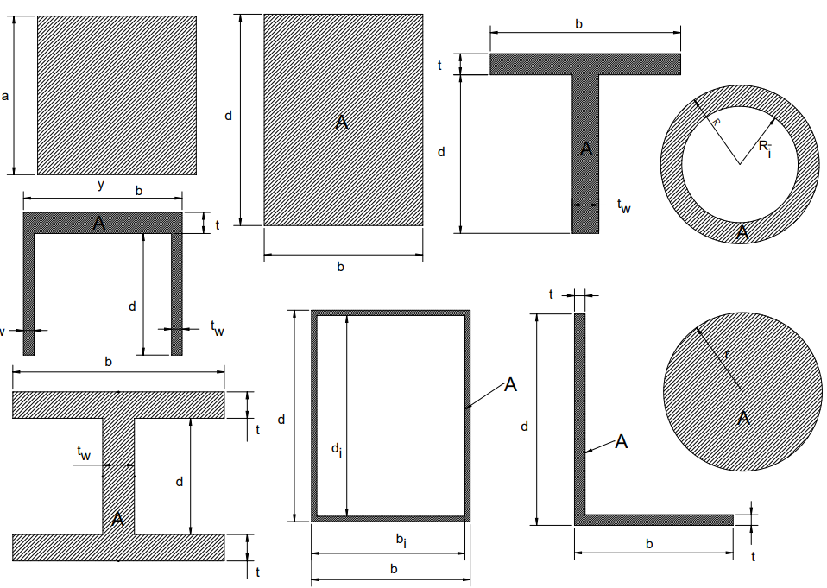Area of section(A):

Total amount of space inside the section.

Significance: Used for calculations of stress, strain, and moments of inertia.

Inputs: dimension of cross-section

Drop down

Area of various cross-section are:

1. Square: A=a2

2. Rectangle: A=dxb

3. Hollow rectangle: A=(dxb) – (dixbi)

4. Circle: A=π×r2

5. Hollow circle or pipe: A=π(R-Ri)

6. L bar: A=t(b+d−t)

How to find L bar area

Consider we have two different rectangle having length =d&b & width t for both rectangle

A=A(rectangle1) + A(rectangle1) – area of intersecting of both rectangle

A=bt+dt-txt

A=t(b+d−t)

7. I beam: A=twd+2tb

How to find I Bean area

Consider we have three rectangle

Rectangle X (web) having length =d & width = tw

Rectangle y & z (flanges) having same length =b & width = t

Area(A)= A(rectangle X) + A(rectangle Y) +A(rectangle Z)

A= twd+tb+tb

A=twd+2tb

8. C channel: A=tb+2twd

How to find C channel area

Consider we have three rectangle

Rectangle X (web) having length =b & width = t

Rectangle y & z (flanges) having same length =d & width = tw

Area(A)= A(rectangle X) + A(rectangle Y) +A(rectangle Z)

A= tb + twd + twd

A=tb+2twd

9. T section: A=tb+twd

How to find T section area

Consider we have two different rectangle

Rectangle X (flange) having length =b & width = t

Rectangle y (web) having same length =d & width = tw

A=A(rectangleX) + A(rectangleY)

A=bt+ twd

A= tb+twd

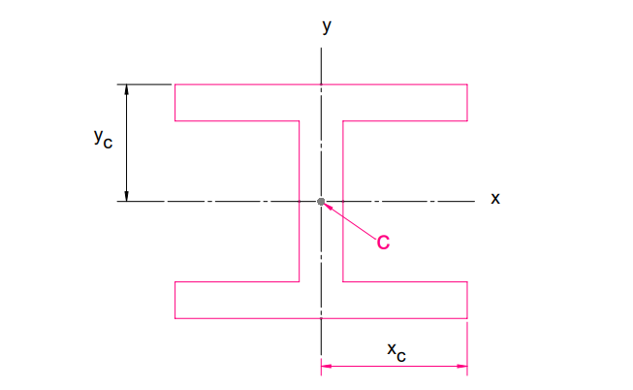Principle axis: Main axes of cross section or

member which are perpendicular and intersect each other at the center of area or centroid.

Centroid: Center of mass for the geometric shape

or point within the section where the area could be

balanced without any rotation.

Drop down:

Significances:

1. Used to find the moment of inertia.
2. Centroid is crucial for designing stable structures.
3. For determining the location of the neutral axis of section or member.

Inputs: dimensions for cross-sections

Formulas of centroid for various section:

1. Square: yc​=xc​=a/2
2. Rectangle: *Xc*​=*b*/2 & yc=d/2
3. Hollow rectangle: *Xc*​=*b*/2 & yc=d/2
4. Tee section: yc​=(bt2+tw​d(2t+d)​)/ 2(tb+tw​d) & xc​=b/2
5. Channel section: yc​=(bt2+2tw​d(2t+d)​)/ 2(tb+2tw​d) & xc​=b/2
6. Wide-flange beam: xc​=b/2 & yc​=d/2+t
7. Angle: xc​=(b2+dt−t2)/(2(b+d−t)​) & yc=(d2+bt-t2)/(2(b+d-t))
8. Circle: yc​=xc​=R
9. Hollow circle or pipe: yc​=xc​=R

Area Moments of Inertia (Ix, Iy) (second moment of area):

Measures of the distribution of area around the

centroidal axes. Indicate the section's resistance to

bending and torsion about its principal axes.

Drop down:

geometrical property that Reflects how the area of a cross-section is distribute relative to a particular axis and Measure of cross-section resistance to bending due to its shape.

Significance: Resistance of an area against the applied moment (bending or twisting moment) about an axis.

Inputs or requirements:

dimensions of cross-section

formula: Ix= ∫y2dA & Iy= ∫x2dA

Where y = distance from the x-axis to area dA

x = distance from the y-axis to area dA

formulas for various sections:

1. square Ix​=Iy​=a4/12
2. rectangle: Ix​=bd3/12, Iy​=db3/12
3. hollow rectangle: Ix​=(bd3-bidi3)/12 & Iy​=(db3-dibi3)/12
4. t section: Ix​=(b(d+t)3-d3(b-tw))/3 – A(d+t-yc)2 & Iy​=(tb3+dtw2)/12
5. c channel: Ix​=(b(d+t)3-d3(b-2tw))/3 – A(d+t-yc)2 & Iy=((d+t)b3-d(b-2tw)3)/12
6. I beam: Ix=(b(d+2t)3-(b-tw)d3)/12 & Iy=(b3t)/6 + (tw3d)/12
7. L angle: Ix​=(bd3-(b-t)(d-t)3)/3 – A(d-yc)2 & Iy​=(db3-(d-t)(b-t)3)/3 – A(b-xc)2
8. Circle: Ix​=Iy​= πR4/4
9. Hollow Circle: Ix​=Iy​= π(R4-Ri4)/4

Section modulus: Geometrical property of cross

section used to design beam or flexural member. Measure

section's ability to resist bending or flexural deformation.

Drop down

Significance of section modulus:

1. It tell us about the strength of beam, higher section modulus means high strength of the beam.
2. Higher section modulus indicates greater resistance to bending, making it a crucial factor in designing structures.

Requirements or input:

1. Dimensions of Cross section.
2. maximum distance from the neutral axis to the surface of the member.

Formula:

s = I/c

Where I is second moment of inertia (area moment of inertia)

& c is maximum distance from the neutral axis to the surface of the member.

Formulas for various sections:

1. Square: sx=sy=ix/yc=a3/6
2. Rectangle: sx=ix/yc=bd2/6 & sy=iy/xc=db2/6
3. Hollow rectangle: sx=ix/yc  & sy=iy/xc
4. Tee section: sx=ix/d+t-yc & sy=iy/xc
5. C channel: sx=ix/d+t-yc & sy=iy/xc  , A=tb+2tw​d
6. I section: sx=ix/yc  & sy=iy/xc
7. L angle: sx=ix/d-yc  & sy=iy/b-xc , A=t(b+d-t)
8. Circle: sx=sy=ix/yc=π​R3/4
9. Hollow circle or pipe: sx=sy=ix/yc

Units: mm3

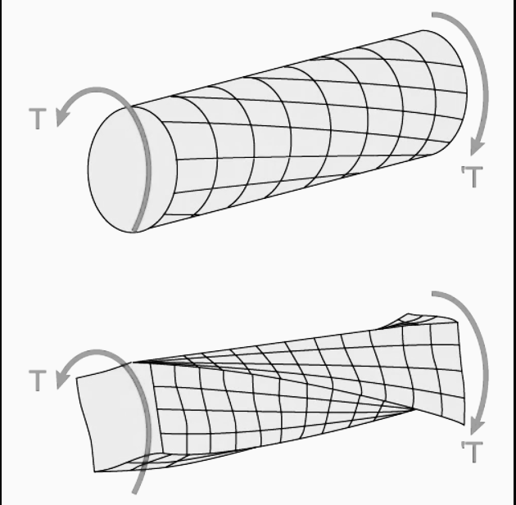

Torsional constant:

Geometrical property of bar cross-section that describes

its resistance to torsional deformation during torsion.

dropdown

Significance: Crucial for designing shafts that transmit power in machinery. Knowing the torsional constant allows for the design of shafts that can safely transfer torque without excessive twisting or failure.

Formula

ϕ=TL/kg or k =TL/ ϕg

​In this equation:

ϕ — Angle of twist;

T — Torque applied to the beam;

L — Shaft length;

G — Shear modulus of the shaft material

K — Beam torsional constant, the one we get with this calculator.

The torsional constant in this formula has the same function as the polar moment (polar moment of inertia - describes a cross sections resistance to torsion due to its shape or measure the strength (max. applicable torque) of shaft )circular beam, but we termed it here with the

K symbol to differentiate both.

Formula for various sections:

1. Circle: K= (πr4)/2
2. Ellipse: k=(πa3b3)/ (a3 + b3)
3. Hollow ellipse k=((πa3b3) (1- q4))/ (a3 + b3) where q = a0/a = b0/b
4. Thin walled ellipse: k=(4π2t(a-t/2)2(b-t/2)2)/U where u is length of median, U=π(a+b−t)(1+(0.258(a-b)2)/(a+b-t)2)
5. Square: K=9a4/64
6. Rectangle: k=ab3/3 - 0.21b4+0.0175b8/a4
7. Hollow walled rectangle: (2tt1(a−t)2(b−t1)2)/(at+bt1-t2-t12)
8. I section: K=2K1+K2+2αD4

K1=(ab3)/3 – 0.21b4 + 0.0175b8/a4

K2=cd3/3

D=t/t1(0.15+0.1r/b)

α = t/t1(0.15+0.1r/b)

if b<d, then t/t1= b/d

if b>d, then t/t1= d/b

Radius of gyration(k): distance at which entire area of cross

section has to be conertrated in thin strip in order to get the

same moment of inertia.

Drop down

Formula: kx=(Ix/A)1/2

Ky=(Iy/A)1/2